Areesha Raheel
55039
cybersecurity

Assignment 2: CMS and Application Vulnerability Assessment
application-level vulnerability detection using specialized tools.

WPScan
WPScan is a WordPress vulnerability scanner used to detect version info, vulnerable plugins, themes, and exposed WordPress files.
Example Command:
wpscan --url (your site link )--enumerate p

WPScan
Objective: To identify WordPress-related vulnerabilities (where applicable).
Method: CMS vulnerability scanning.
Result: No critical exploitable vulnerabilities were confirmed.
Security Impact: CMS components must be regularly updated.
Risk Level: Low
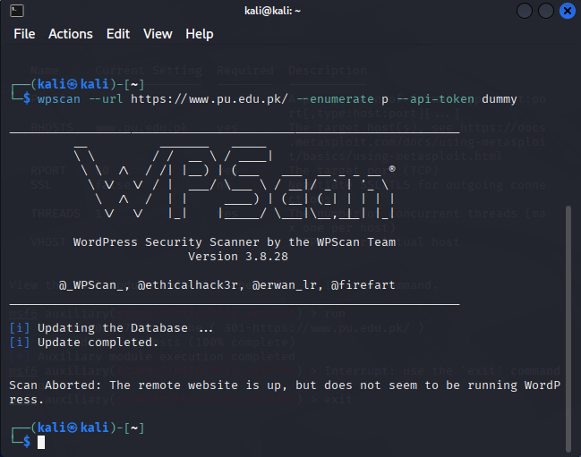

SearchSploit
SearchSploit is an offline tool that allows searching of the Exploit Database for public exploits based on software versions.
Example Command:
searchsploit whatweb your site link→ find versions → searchsploit <version string>

